|  |  |
| --- | --- |
| Name: Arjun Mehta | B. Tech Cybersecurity |
| K036 | 11-01-25 |

**P&S Lab 2**

Classwork:

#write a vector of length 10 of 3 colours

color_vector <- c('Blue','Green','Red')

cafac = factor(color_vector)

nlevels(cafac)

summary(cafac)

shifts = c('Morning','Afternoon','Evening','Night','Morning','Afternoon','Evening','Night','Morning','Afternoon')

lengths(shifts)

shiftsfac = factor(shifts,order=TRUE,levels=c('Morning','Afternoon','Evening','Night'))

nlevels(shiftsfac)

summary(shiftsfac)

shiftsfac

data1=read.csv("C:\\Users\\mpstme.student\\Downloads\\cancer.csv")

data2$treatment

f1=factor(data1$treatment)

nlevels(f1)

summary(f1)

f2=factor(data1$cancerlevel,order=TRUE,levels=c(1,2,3))

summary(f2)

f2

Output:

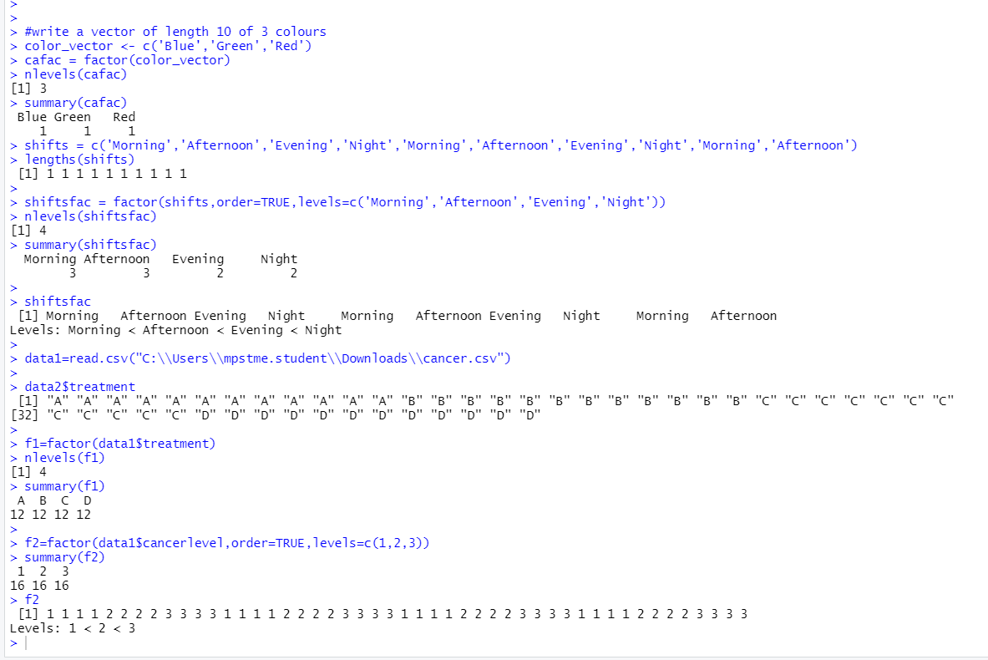

Questions:

1. Create a csv file for the following data

## Source Cu

## 1 Site1 19.700

## 2 Site2 10.643

## 3 Site1 33.792

## 4 Site2 5.353

## 5 Site2 19.890

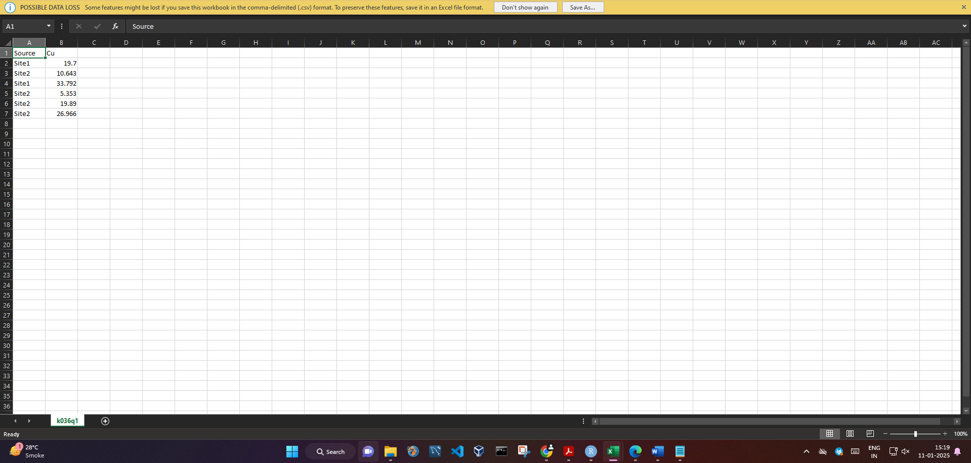

2. Create a csv file for the following data

## City ProductA ProductB ProductC

## 1 Seattle 23 11 12

## 2 London 89 6 56

## 3 Tokyo 24 7 13

## 4 Berlin 36 34 44

## 5 Mumbai 3 78 14

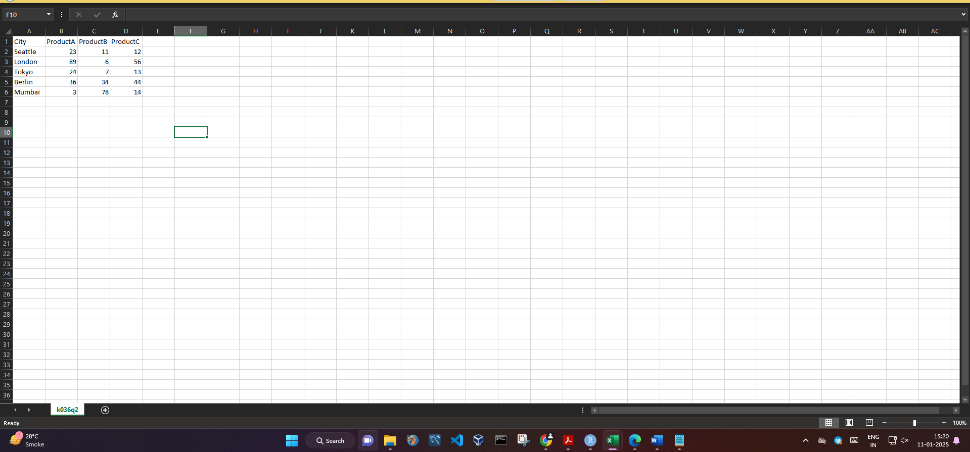

3.The dataset swiss contains a standardized fertility measure and various socioeconomic indicators for each of 47 French-speaking provinces of Switzerland in about 1888. Import this dataset.

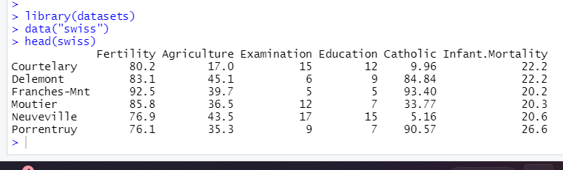

4. Write a R program to create an ordered factor from data of minimum 20 elements consisting of the names of months.

months <- c("January", "February", "March", "April", "May", "June", "July", "August", "September", "October", "November", "December","January", "February", "March", "April", "May", "June", "July", "August")

ordered_months <- factor(months, levels = c("January", "February", "March", "April", "May", "June", "July", "August", "September", "October", "November", "December"), ordered = TRUE)

print(ordered_months)

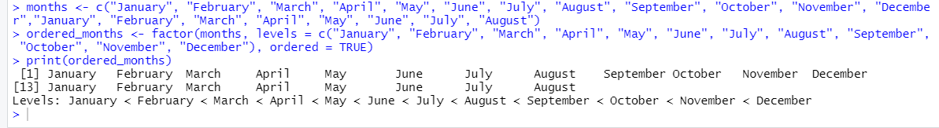

5. Create a Simple Data Frame: Construct a data frame containing the following information:

• Columns: Product, Price, Quantity

• Add details for 4 different products.

Rename Columns in a Data Frame: Create a data frame with columns A, B, and C, and then rename them to Subject, Marks, and Grade.

products <- data.frame(

Product = c("Product1", "Product2", "Product3", "Product4"),

Price = c(10.99, 20.49, 15.00, 25.75),

Quantity = c(100, 150, 200, 250)

)

print(products)

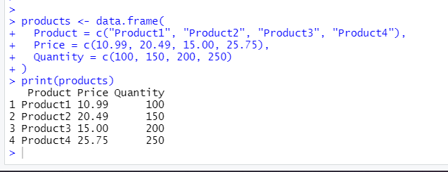

df <- data.frame(

A = c("Math", "Science", "History", "Art"),

B = c(85, 90, 78, 92),

C = c("A", "A", "B", "A")

)

colnames(df) <- c("Subject", "Marks", "Grade")

print(df)

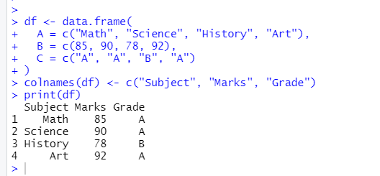

6. Combine Two Data Frames: Create two data frames:

• Data Frame 1: Name, Department

• Data Frame 2: Name, Marks Combine them into a single data frame using merge() based on the Name column.

df1 <- data.frame(

Name = c("Alice", "Bob", "Charlie", "David"),

Department = c("HR", "Finance", "IT", "Marketing")

)

df2 <- data.frame(

Name = c("Alice", "Bob", "Charlie", "David"),

Marks = c(85, 90, 78, 92)

)

combined_df <- merge(df1, df2, by = "Name")

print(combined_df)

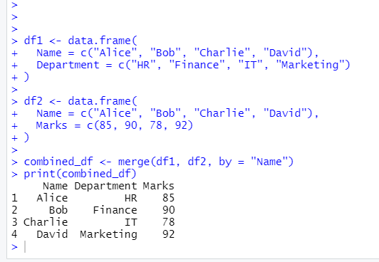

7. Check Data Frame Properties: Write a script to create a data frame and then display the number of rows, columns, and the structure (str()) of the data frame.

df <- data.frame(

Name = c("Alice", "Bob", "Charlie", "David"),

Age = c(25, 30, 35, 40),

Department = c("HR", "Finance", "IT", "Marketing")

)

num_rows <- nrow(df)

num_columns <- ncol(df)

structure <- str(df)

print(paste("Number of rows:", num_rows))

print(paste("Number of columns:", num_columns))

print(structure)

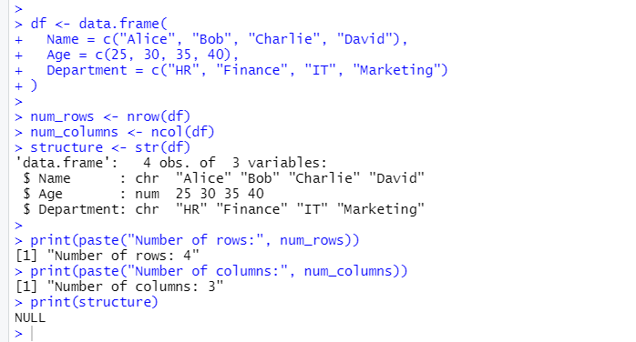

8. Create a Data Frame from Vectors: Using the following vectors:

Copy code

Names <- c("John", "Sara", "Ali", "Nina")

Ages <- c(20, 21, 22, 23)

Construct a data frame and print it.

Names <- c("John", "Sara", "Ali", "Nina")

Ages <- c(20, 21, 22, 23)

df <- data.frame(Names, Ages)

print(df)

